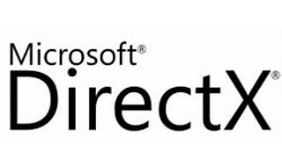



Explore

[**DirectX** is a collection of application programming interfaces (APIs) that provide low-level access to hardware components like video cards, the sound card, and memory, primarily used for multimedia tasks, especially game programming and video, on Microsoft platforms1](https://www.windowscentral.com/what-directx-why-does-matter-gaming).

Here are **five free resources** where you can learn more about DirectX:

1. [**Microsoft Learn: DirectX Graphics**](https://learn.microsoft.com/en-us/windows/win32/directx): Explore tutorials, articles, and documentation related to DirectX graphics for 2D and 3D graphics, text, and composition.
2. [**DirectXTutorial.com**](http://www.directxtutorial.com/LessonList.aspx?listid=11): A series of lessons covering topics like creating a window, input handling, and real-time message loops.
3. [**Create your first Windows app using DirectX**](https://learn.microsoft.com/en-us/windows/win32/direct3dgetstarted/building-your-first-directx-app): A step-by-step guide to building a DirectX app using C++.
4. [**Learning DirectX 12 – Lesson 1**](https://www.3dgep.com/learning-directx-12-1/): Start from scratch and learn how to create a DirectX 12 application, including querying display adapters, creating a device, and implementing N-buffered rendering.
5. [**DirectX Landing Page**](https://devblogs.microsoft.com/directx/landing-page/): A compilation of descriptions and links to various DirectX components currently in development.

Happy learning! 🎮🚀